LITERATURE SURVEY

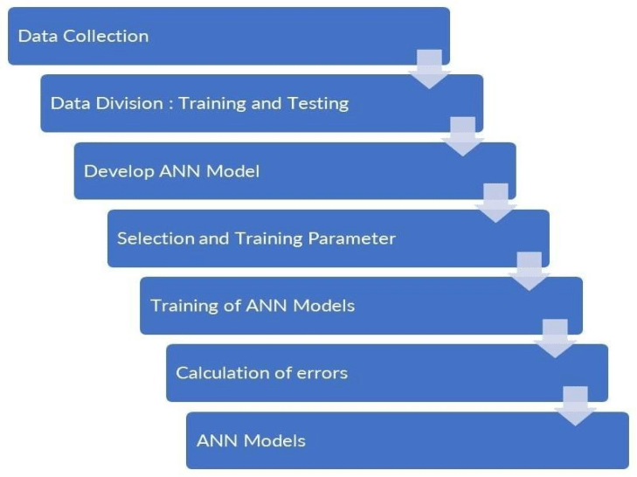

• [1] Anusha Garlapati, Doredla Radhakrishna, 2021,” Stock price prediction using Facebook Prophet models”, 2021 6th International Conference for Convergence in Technology(I2CT)Pune, India.

• [2] Emir Zunic, Kemel Kojiniec, 2020, “Application of Facebook Prophet Algorithm”, International Journal of Computer Science & Information Technology (IJCSIT).

• [3] D. H. D. Nguyen, L. P. Tran, and V. Nguyen,2019, “Predicting stock prices using dynamic LSTM models,” in International Conference on Applied Informatics. Springer, pp. 199–212.